Test Case: tc003_SPX_Dev5_Validar_Funcionalidad_Botones_Add_Remove_Administrador_Roles_Menu
Step 1 - Enter username and password and click to button Enter : Credentials Entered
Image file-name: QC_Testing-runTestMultipleTimes-nov. 20 2025, 05 50 03 p. m.

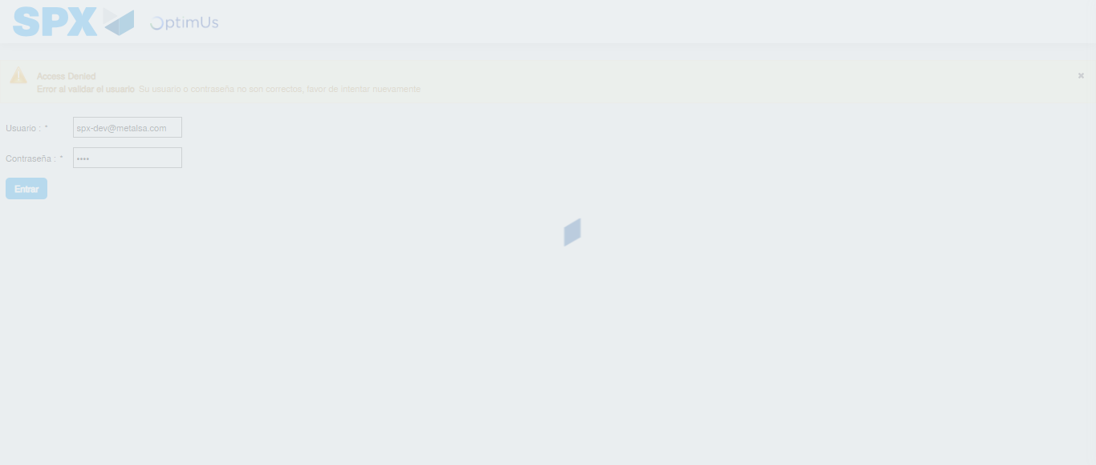Image file-name: QC_Testing-runTestMultipleTimes-nov. 20 2025, 05 50 04 p. m.

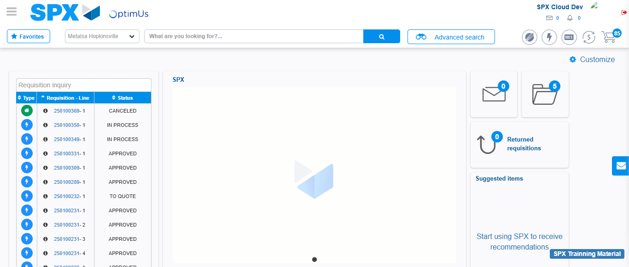Image file-name: QC_Testing-tc001_SPX_Dev5_Validar_Filtro_Campo_MenuName_Administrador_Roles_Menu-nov. 20 2025, 05 50 47 p. m.

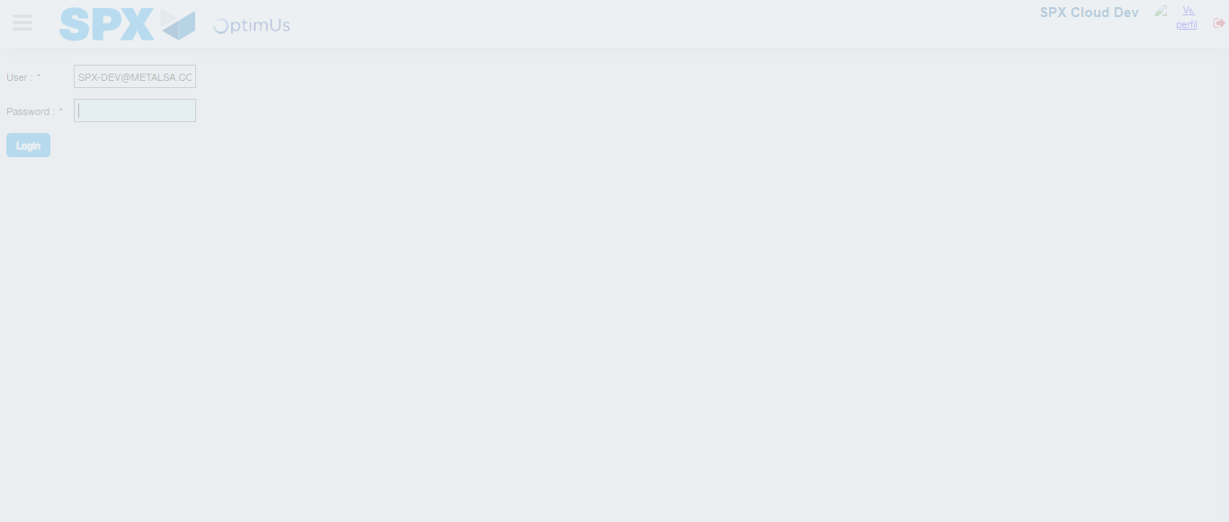Image file-name: QC_Testing-tc002_SPX_Dev5_Validar_Filtro_Campo_URLPath_Administrador_Roles_Menu-nov. 20 2025, 05 51 12 p. m.

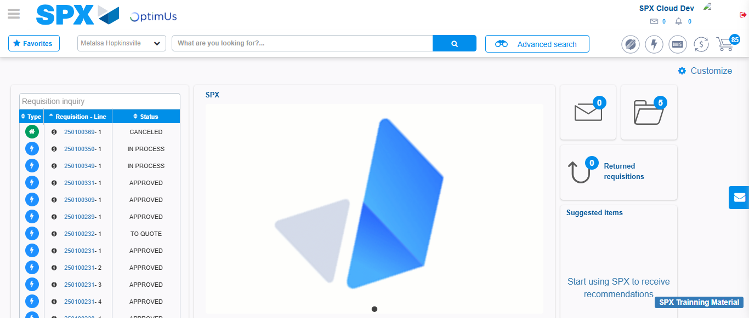Image file-name: QC_Testing-tc003_SPX_Dev5_Validar_Funcionalidad_Botones_Add_Remove_Administrador_Roles_Menu-nov. 20 2025, 05 51 28 p. m.

Step 2 - Select to UEN and Access to Administrador Roles Menu: UEN Correctly selected and Correct access
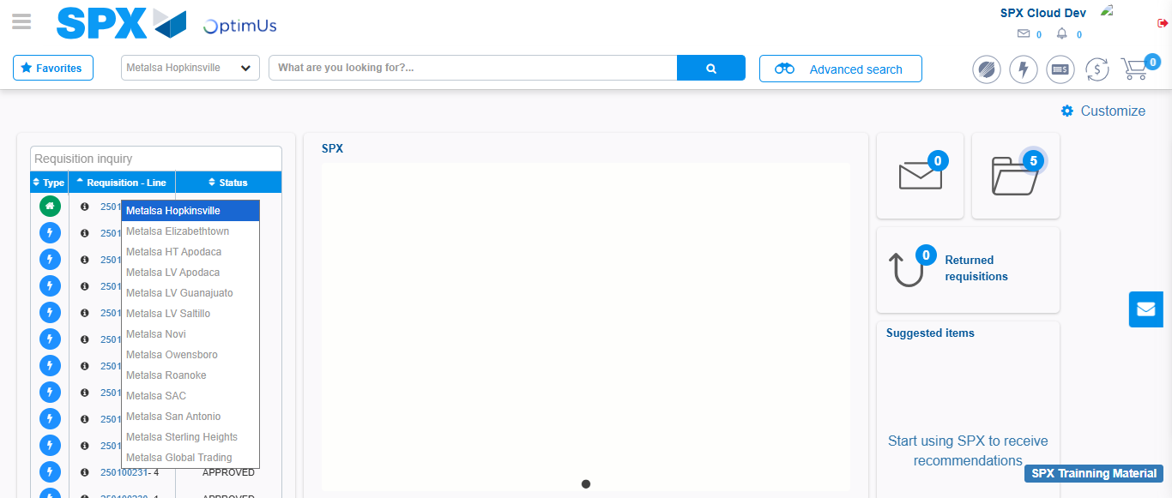Image file-name: QC_Testing-runTestMultipleTimes-nov. 20 2025, 05 50 14 p. m.

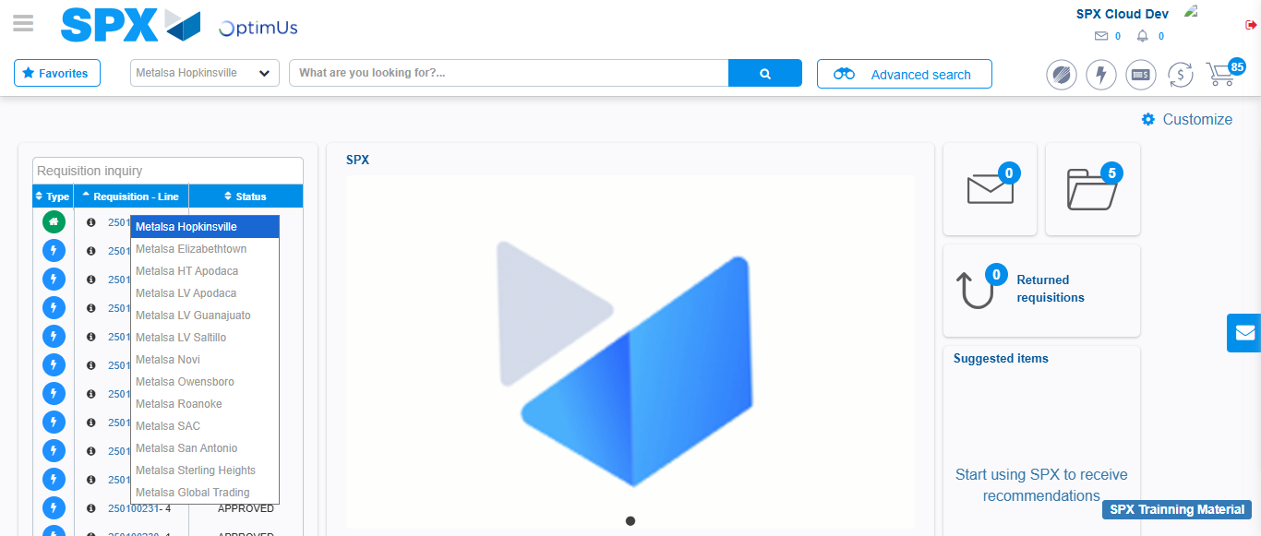Image file-name: QC_Testing-runTestMultipleTimes-nov. 20 2025, 05 50 25 p. m.

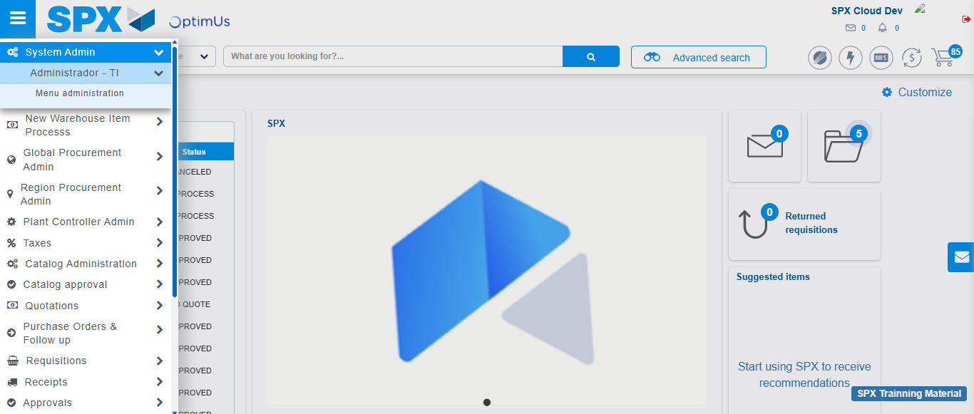Image file-name: QC_Testing-runTestMultipleTimes-nov. 20 2025, 05 50 26 p. m.

Image file-name: QC_Testing-runTestMultipleTimes-nov. 20 2025, 05 50 30 p. m.

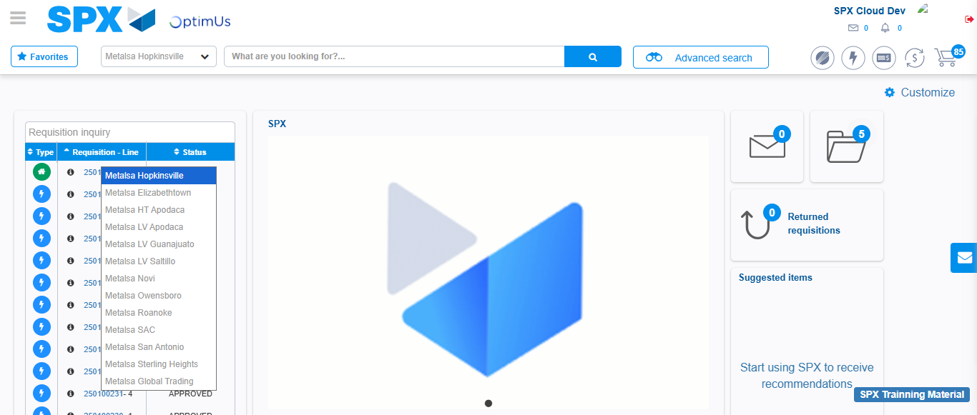Image file-name: QC_Testing-tc001_SPX_Dev5_Validar_Filtro_Campo_MenuName_Administrador_Roles_Menu-nov. 20 2025, 05 50 48 p. m.

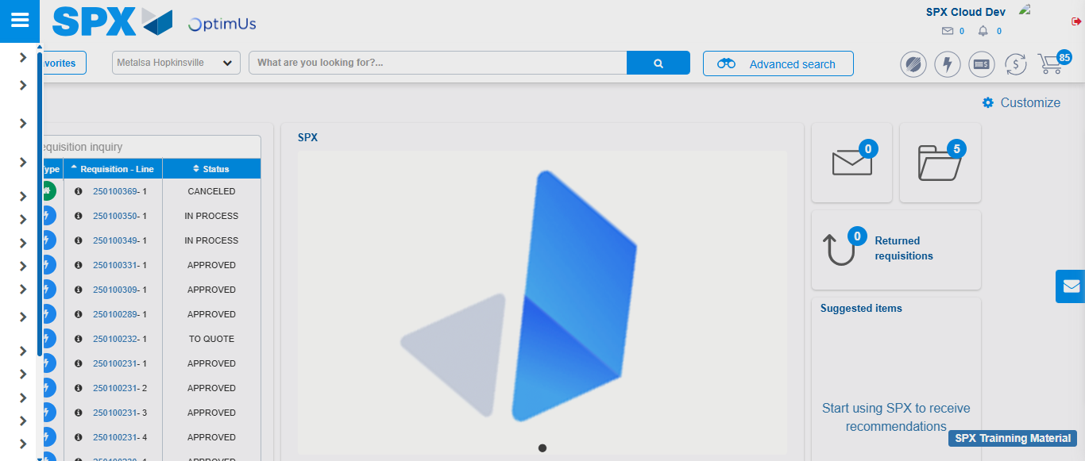Image file-name: QC_Testing-tc001_SPX_Dev5_Validar_Filtro_Campo_MenuName_Administrador_Roles_Menu-nov. 20 2025, 05 50 59 p. m.

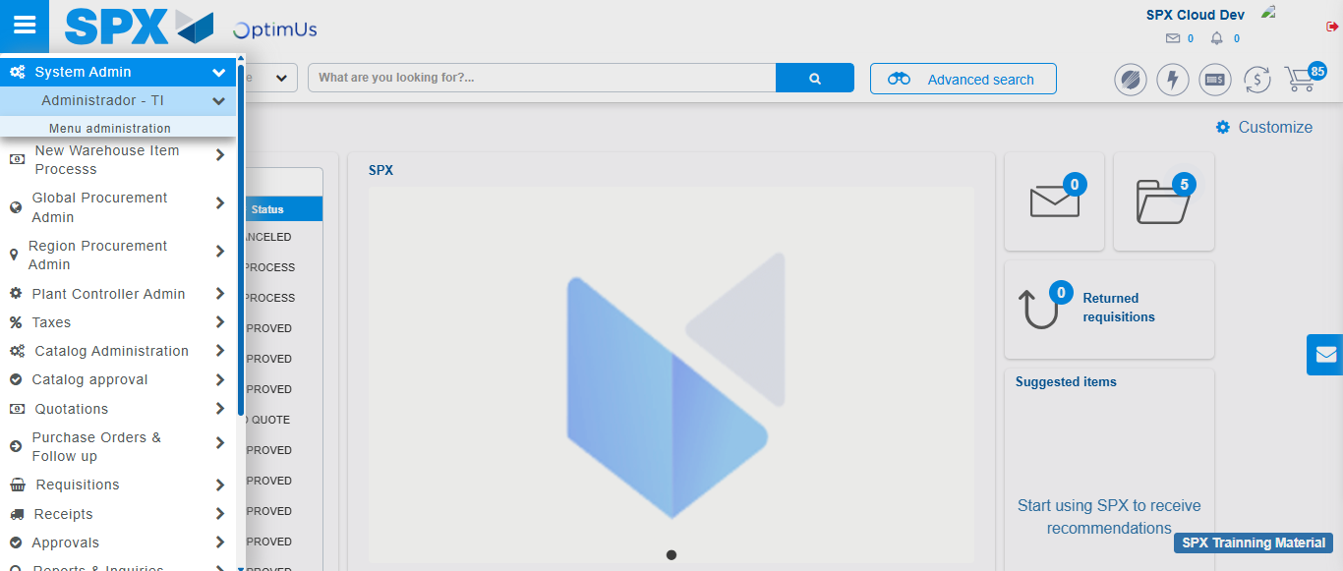Image file-name: QC_Testing-tc001_SPX_Dev5_Validar_Filtro_Campo_MenuName_Administrador_Roles_Menu-nov. 20 2025, 05 51 00 p. m.

Image file-name: QC_Testing-tc001_SPX_Dev5_Validar_Filtro_Campo_MenuName_Administrador_Roles_Menu-nov. 20 2025, 05 51 03 p. m.

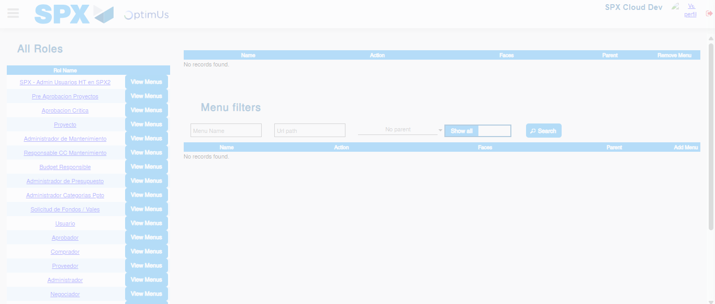Image file-name: QC_Testing-tc001_SPX_Dev5_Validar_Filtro_Campo_MenuName_Administrador_Roles_Menu-nov. 20 2025, 05 51 04 p. m.

Image file-name: QC_Testing-tc003_SPX_Dev5_Validar_Funcionalidad_Botones_Add_Remove_Administrador_Roles_Menu-nov. 20 2025, 05 51 28 p. m.

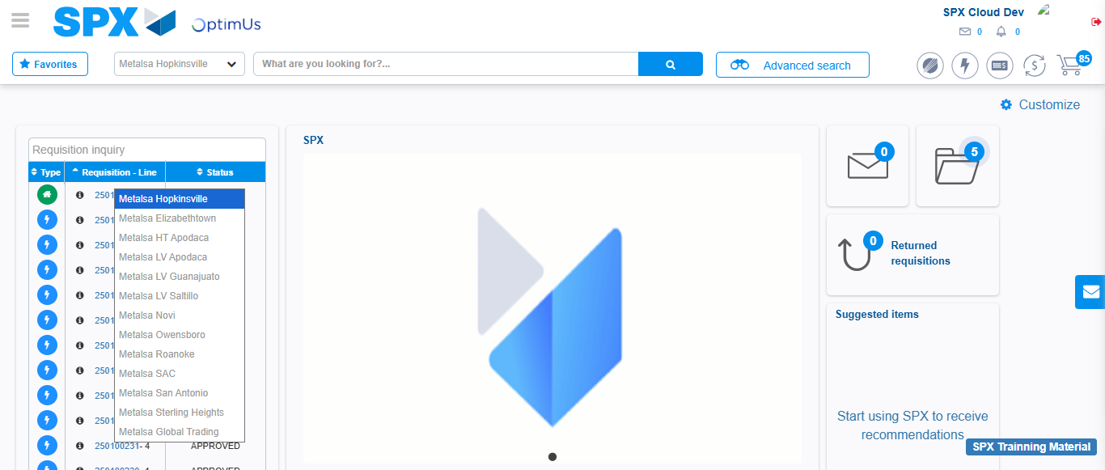Image file-name: QC_Testing-tc003_SPX_Dev5_Validar_Funcionalidad_Botones_Add_Remove_Administrador_Roles_Menu-nov. 20 2025, 05 51 29 p. m.

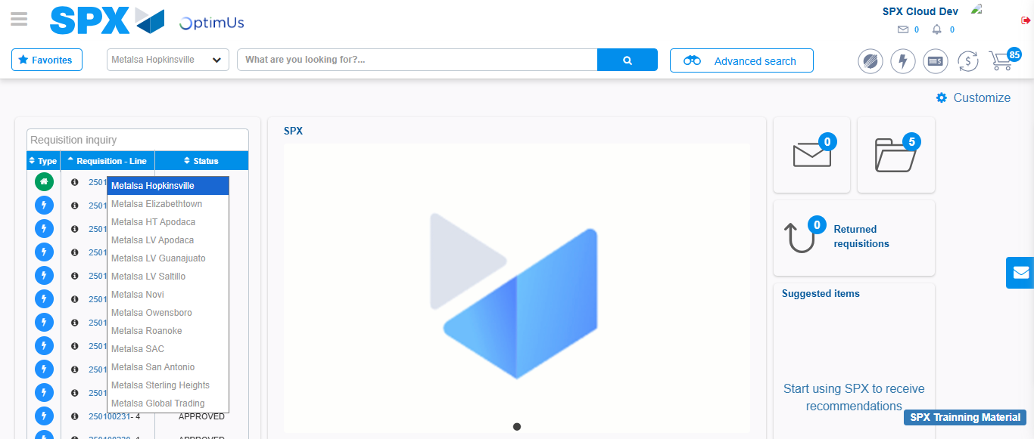Image file-name: QC_Testing-tc003_SPX_Dev5_Validar_Funcionalidad_Botones_Add_Remove_Administrador_Roles_Menu-nov. 20 2025, 05 51 39 p. m.

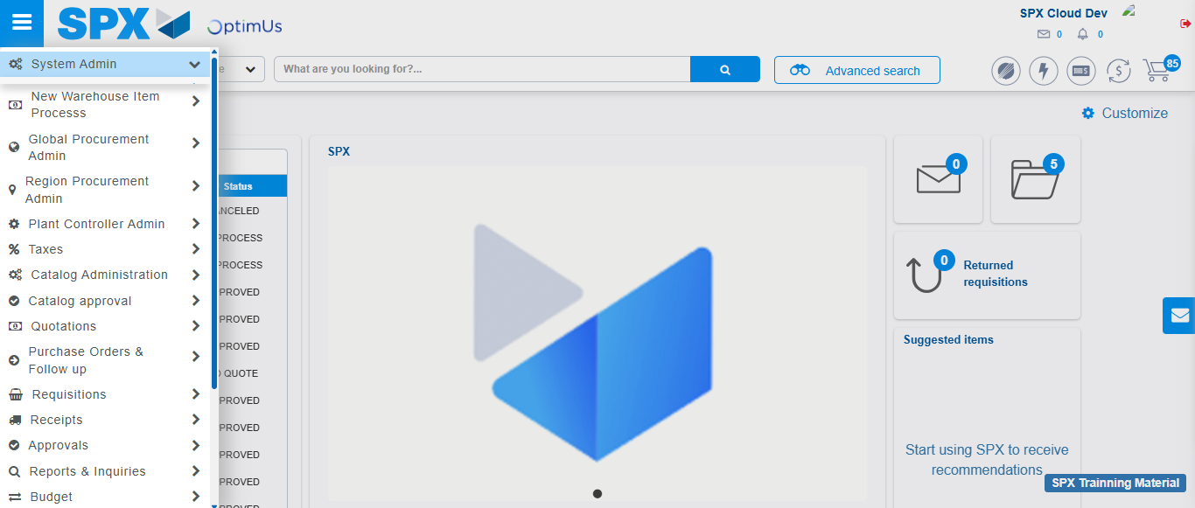Image file-name: QC_Testing-tc003_SPX_Dev5_Validar_Funcionalidad_Botones_Add_Remove_Administrador_Roles_Menu-nov. 20 2025, 05 51 40 p. m.

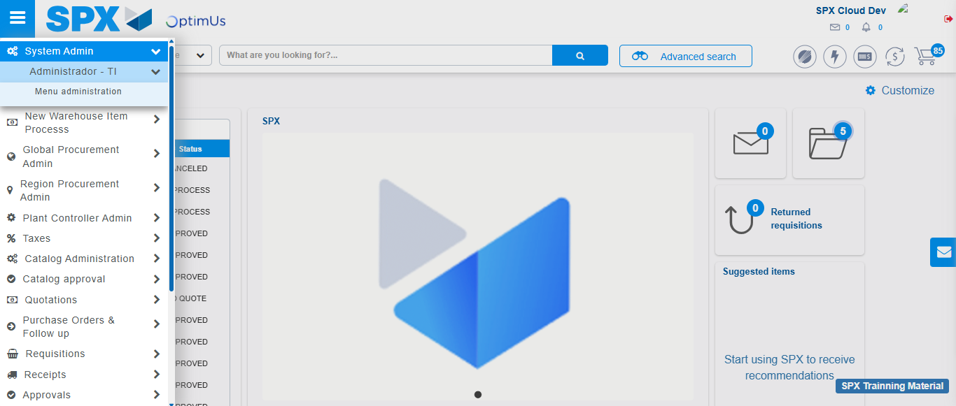Image file-name: QC_Testing-tc003_SPX_Dev5_Validar_Funcionalidad_Botones_Add_Remove_Administrador_Roles_Menu-nov. 20 2025, 05 51 41 p. m.

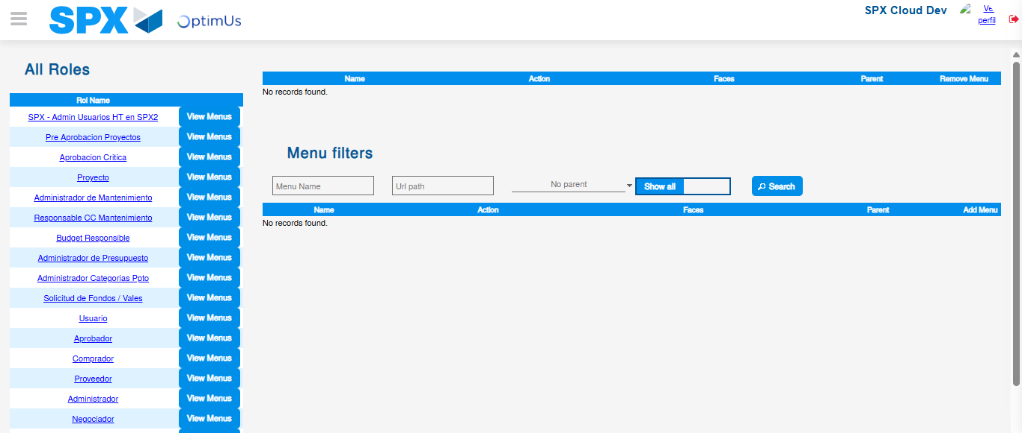Image file-name: QC_Testing-tc003_SPX_Dev5_Validar_Funcionalidad_Botones_Add_Remove_Administrador_Roles_Menu-nov. 20 2025, 05 51 42 p. m.

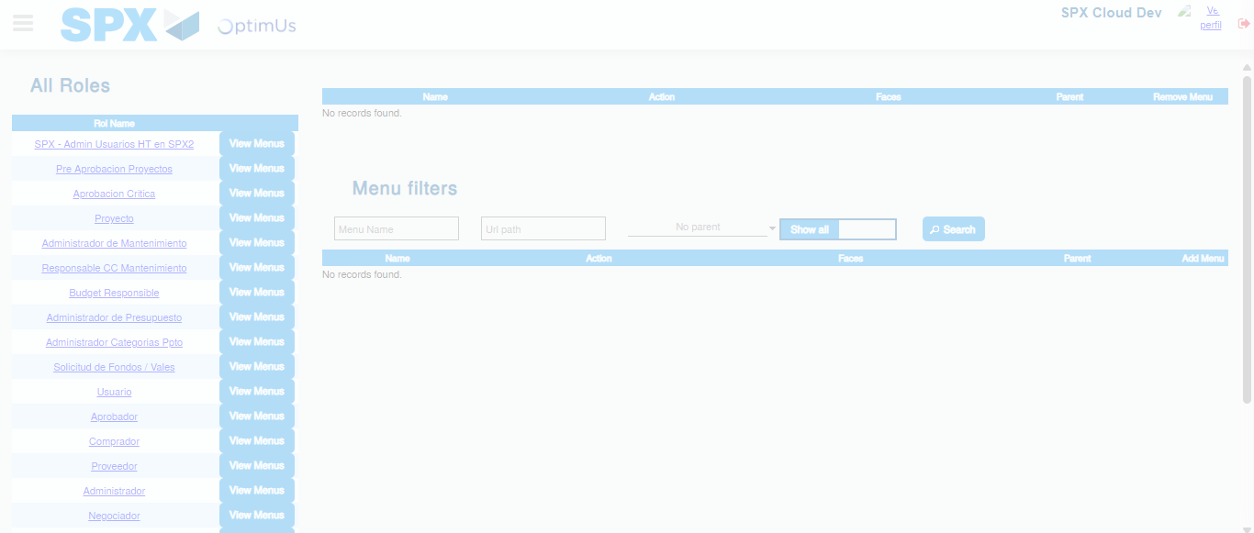Image file-name: QC_Testing-tc003_SPX_Dev5_Validar_Funcionalidad_Botones_Add_Remove_Administrador_Roles_Menu-nov. 20 2025, 05 51 43 p. m.

Step 3 - Click to Buttons View Menu and Search Filter with Menu Name and Add new record and Delete Record: Correct Search and Record successfully added and Record successfully deleted
Image file-name: QC_Testing-runTestMultipleTimes-nov. 20 2025, 05 50 30 p. m.

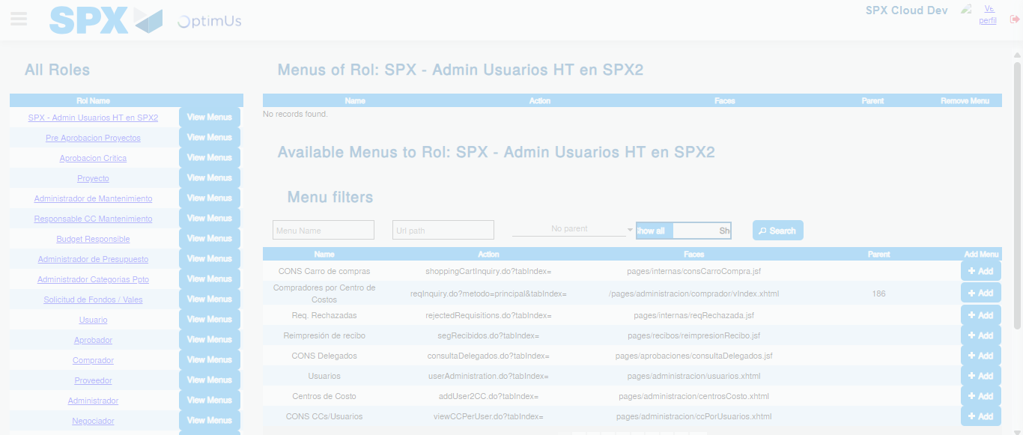Image file-name: QC_Testing-runTestMultipleTimes-nov. 20 2025, 05 50 31 p. m.

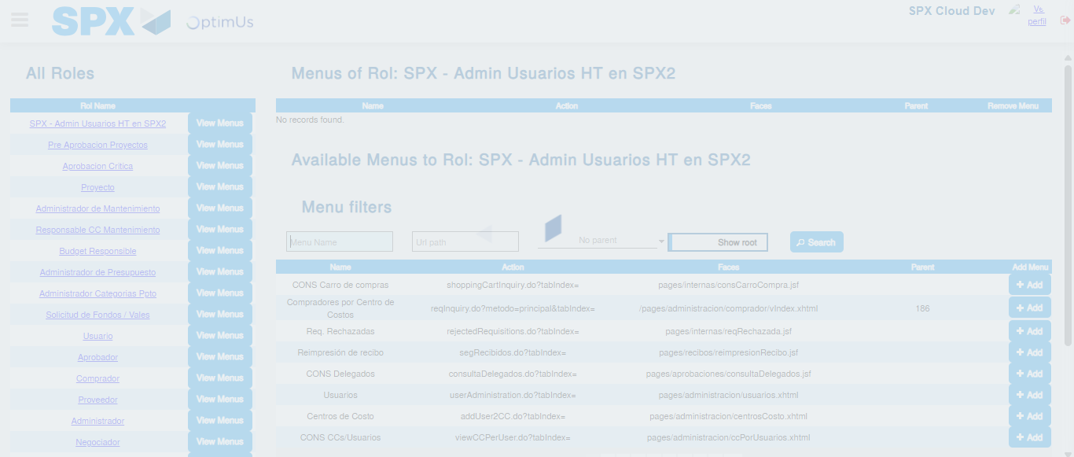Image file-name: QC_Testing-runTestMultipleTimes-nov. 20 2025, 05 50 32 p. m.

Image file-name: QC_Testing-tc001_SPX_Dev5_Validar_Filtro_Campo_MenuName_Administrador_Roles_Menu-nov. 20 2025, 05 51 04 p. m.

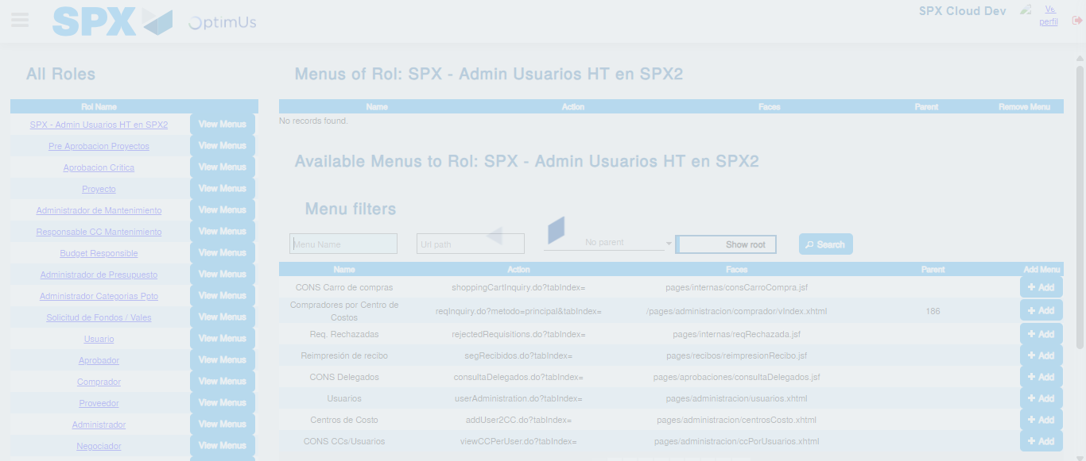Image file-name: QC_Testing-tc001_SPX_Dev5_Validar_Filtro_Campo_MenuName_Administrador_Roles_Menu-nov. 20 2025, 05 51 05 p. m.

Image file-name: QC_Testing-tc003_SPX_Dev5_Validar_Funcionalidad_Botones_Add_Remove_Administrador_Roles_Menu-nov. 20 2025, 05 51 43 p. m.

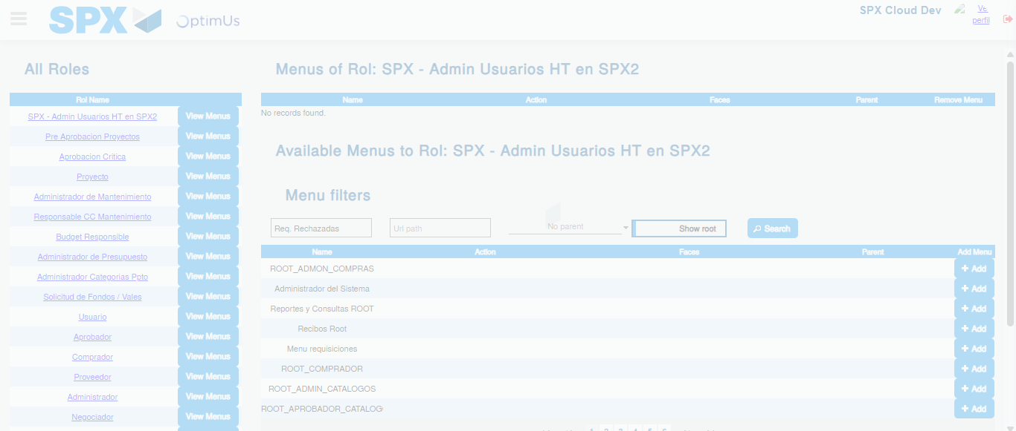Image file-name: QC_Testing-tc003_SPX_Dev5_Validar_Funcionalidad_Botones_Add_Remove_Administrador_Roles_Menu-nov. 20 2025, 05 51 44 p. m.

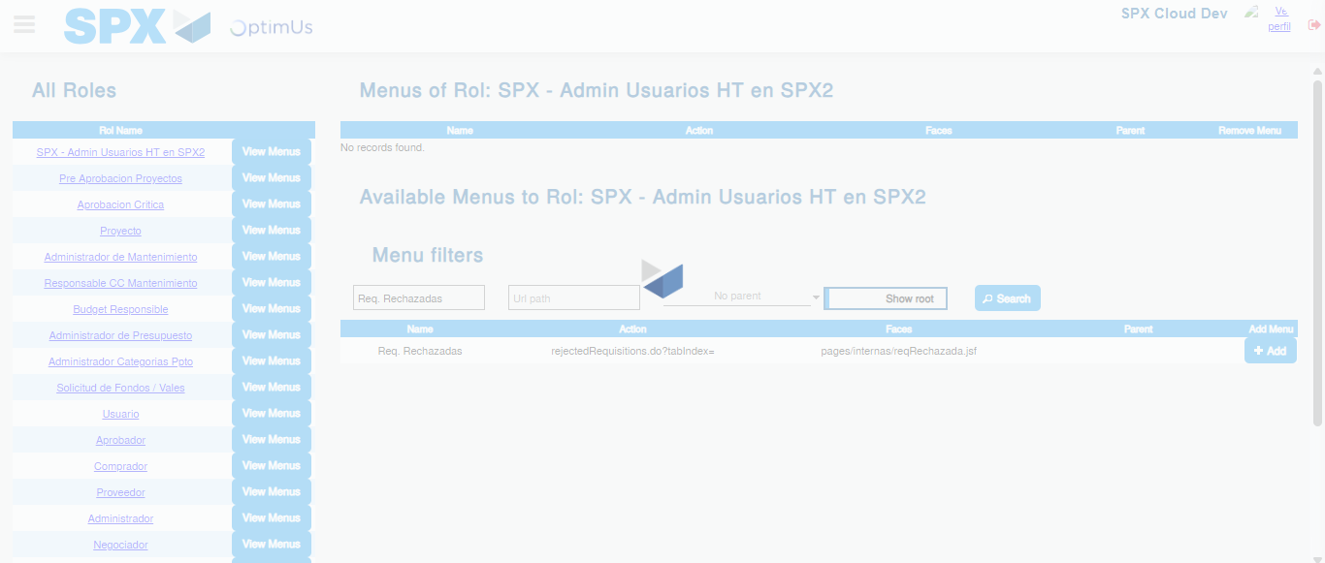Image file-name: QC_Testing-tc003_SPX_Dev5_Validar_Funcionalidad_Botones_Add_Remove_Administrador_Roles_Menu-nov. 20 2025, 05 51 45 p. m.

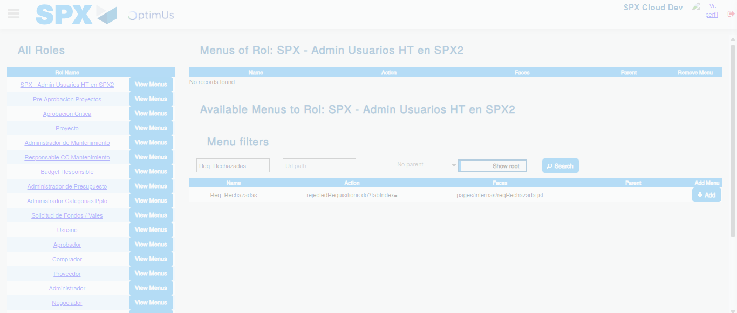Image file-name: QC_Testing-tc003_SPX_Dev5_Validar_Funcionalidad_Botones_Add_Remove_Administrador_Roles_Menu-nov. 20 2025, 05 51 46 p. m.

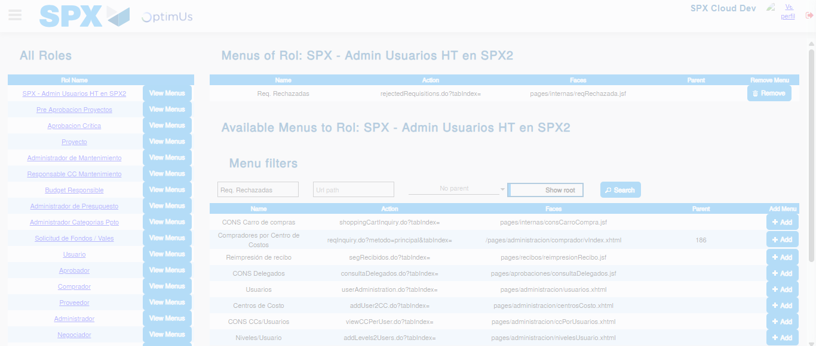Image file-name: QC_Testing-tc003_SPX_Dev5_Validar_Funcionalidad_Botones_Add_Remove_Administrador_Roles_Menu-nov. 20 2025, 05 51 49 p. m.

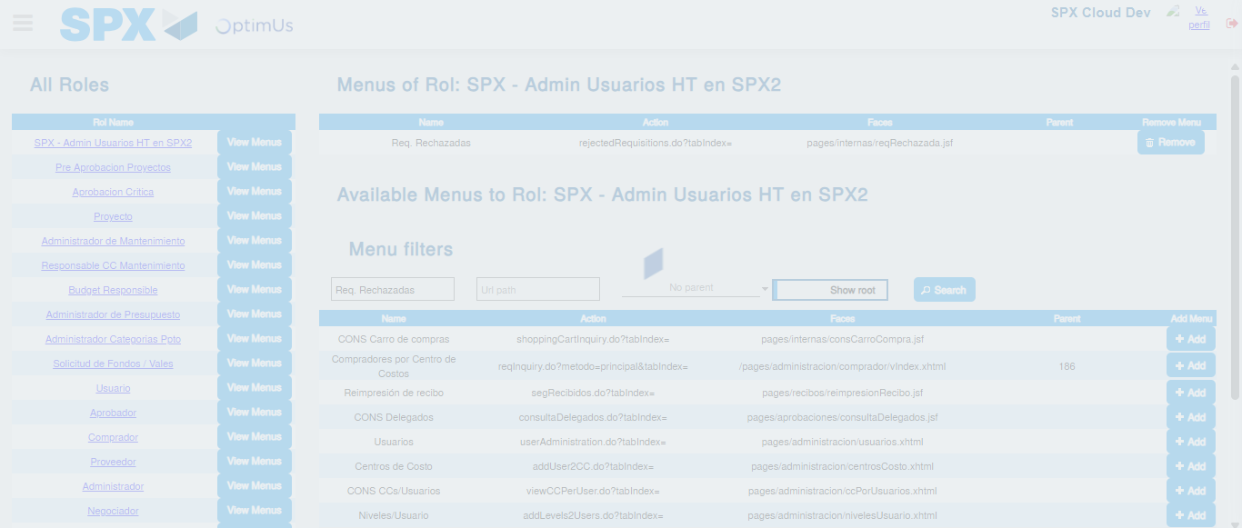Image file-name: QC_Testing-tc003_SPX_Dev5_Validar_Funcionalidad_Botones_Add_Remove_Administrador_Roles_Menu-nov. 20 2025, 05 51 50 p. m.

